
TWT6223 - Web Techniques and Applications
Individual Assignment Report
CryptoXYZ- Cryptocurrency Price Monitoring, Prediction and Portfolio Manager

Student Name: Yeap Boon Shen
Student ID: 242UT244D2
Lab Section: DS1F
Submission Date: 12 June (Thursday) 2025

Table of Contents
1.0 Introduction 3
2.0 OBJECTIVES 3
2.1 Create a User-Friendly Cryptocurrency Monitoring Interface 3
2.2 Display Real-Time and Historical Cryptocurrency Data 4
2.3 Implement Technical Analysis Indicators 4
2.4 Provide a Simple Price Prediction Feature 4
2.5 Develop a Portfolio Management Module 5
2.6 Ensure Responsive Layout and Error Handling 5
3.0 SCOPE OF THE PROJECT 5
4.0 CHOICE OF WEB COMPONENTS 6
5.0 SCREEN SHOTS WITH FIGURE AND CAPTION 9
Figure 1: Initial Landing Page 9
Figure 2: Search Suggestions 9
Figure 3: Apple Stock Analysis with Multiple Indicators 10
Figure 4: Interactive Drawing Tools in Use 11
Figure 5: Price Prediction Feature 12
Figure 6: Mobile Responsive Layout 13
6.0 EXPLANATION OF IMPORTANT SOURCE CODE 13
6.1 Data Fetching Function (fetchData) 13
6.2 RSI Calculation (calculateRSI) 15
6.3 MACD Calculation (calculateMACD) 16
6.4 Price Prediction Using Linear Regression 17
6.5 Interactive Tool Management (Chart Click Handler) 19
7.0 CONTRIBUTION 21
8.0 CONCLUSION 22
9.0 Appendix Source Code 22
9.1 index.html 22
9.2 style.css 25
9.3 script.js 28
Reference 39

Stock Analysis Web Application for Analytic Insight and Prediction

1.0 Introduction
This project is about building a web application that helps people or users monitor cryptocurrency prices and manage their crypto investment portfolio. The Website is called CryptoXYZ. Cryptocurrency data can be confusing because prices change very fast and there are many coins in the market. Beginners may find it difficult to understand price movement while experienced users may need a simple tool to check trends quickly.
CryptoXYZ tries to solve this problem by showing cryptocurrency market data in a clear and interactive way. Users can search for a coin such as Bitcoin, Ethereum, Solana, BNB or XRP. After selecting a coin, the website will show the current price, 24-hour percentage change, market capitalization, historical price chart, volume bars, moving average, RSI, MACD, and a short-term trend forecast.
The system also includes a portfolio management module. Users can enter the quantity of a cryptocurrency they own and the buy price. The system will calculate the total cost, current value, profit or loss amount, and profit or loss percentage. This will helps users understand whether their investment is currently gaining or losing value.
This project is only using HTML5, CSS3, and JavaScript were used to make this web app. There mean it no PHP, Java, server-side script, or database. The CoinGecko public API gives us this cryptocurrency data. The portfolio records are saved using browser localStorage, which is client-side storage. This follows the assignment requirement because all processing is done inside the browser.

2.0 OBJECTIVES

2.1 Create a User Interface Cryptocurrency Monitoring
This objective is to design a simple and user-friendly interface for cryptocurrency monitoring. The interface uses a dark dashboard style because financial charts are usually easier to view on a dark background. The layout is divided into clear sections so users can understand the page quickly.
The left sidebar contains analysis settings, chart tools and a quick watchlist. The top area contains the search bar and market summary. The middle area shows the price chart while the right side shows the portfolio manager. This separation makes the system easier to use because each area has a clear purpose.

2.2 Display Real-Time and Historical Cryptocurrency Data
The CoinGecko API is used by the system to get up-to-date market information like the name of the coin, its symbol, its current price, its price change over the last 24 hours, its market capitalization, and its volume.
The system also gets price data from the past for the chosen cryptocurrency. An interactive line chart shows the historical data. The chart shows people how the price has changed over time. This is useful because it shows users when things are going up, down, or are very unstable.

2.3 Implement Technical Analysis Indicators
The third objective is to provide basic technical analysis indicators. These indicators help users study market movement instead of only looking at raw price values. In this project, I implemented moving average, RSI, MACD and trading volume.
The moving average makes price changes less sharp and shows the market's general direction. RSI helps people figure out if the market is too high or too low. MACD shows how two exponential moving averages are related and helps find changes in momentum. Volume bars show the amount of trading activity during each period.

2.4 Provide a Simple Price Prediction Feature
The fourth objective is to include a basic price prediction feature. The system uses linear regression because it is simple to understand and suitable for an educational web project. The model uses the latest 30 closing prices and calculates a best-fit straight line.
After calculating the line, the system extends it seven days into the future. The predicted values are displayed as a dashed yellow line on the chart. This prediction is not financial advice. It is only a simple mathematical forecast to show the possible direction of the short-term trend.

2.5 Develop a Portfolio Management Module
The fifth objective is to create a portfolio manager. This is an important requirement in the latest assignment guideline. The portfolio module allows users to record their cryptocurrency holdings. Users can choose a coin, enter quantity, and enter buy price.
The system then calculates the total investment cost, current market value, profit or loss amount, and profit or loss percentage. This helps users evaluate their crypto holdings more clearly. The user can also delete a holding if it is no longer needed.

2.6 Ensure the layout Responsive Layout and Error Handling
The last goal is to make sure the website works well and doesn't crash when users enter unexpected information.On desktop screens, the interface uses a sidebar, chart area, and portfolio panel. On smaller screens, the layout stacks vertically so the user can still access all features.
The system includes error messages for empty search input, invalid cryptocurrency search, invalid portfolio quantity, invalid buy price, network errors, and API rate limit problems. These messages are shown using toast notifications. This improves user experience because users can understand what went wrong.

3.0 SCOPE OF THE PROJECT
- Cryptocurrency Search: Users can enter a coin name or a symbol into the search boxes. Then, the system will display matching results from the cryptocurrency market list. Quick watchlist buttons are also provided to allow users to access popular coins more easily.
- Market Data Display: Once the user chooses a coin, details such as the name of the coin, its price, its price change for the last 24 hours, and market cap are displayed by the system.

- Data Visualization: The system displays historical price data using an interactive chart. Users can zoom and pan the chart to examine price movements in more detail. Moving average and trading volume can also be shown on the chart.

- Technical Analysis Tools
Users can enable or disable technical indicators such as the 20-day moving average, RSI, MACD, volume, and trend forecast using checkboxes. This allows users to customize how they analyze the data.

- Technical Analysis Tools:
Users can:
- Draw white trend lines to mark patterns they see
- Place green "Buy" markers at points where they think it's good to buy
- Place red "Sell" markers at points where they think it's good to sell
- Add yellow note markers with custom text for personal observations

- Portfolio Management
Users can manage their crypto holdings by entering the quantity and purchase price. On the basis of the last market price, it will determine the current value and gain or loss for the same. As such, all things pertaining to the portfolio are saved in the localStorage of the browser, which implies that all information will be kept safe from any refresh of the web page.

- Out of Scope Features
This system does not include user authentication, server-side databases, real-time trading execution, or advanced machine learning prediction models. These features require backend infrastructure or paid services, which are beyond the requirements of this project.

4.0 CHOICE OF WEB COMPONENTS
HTML5
Firstly, I used HTML5 to create all the structure of the web page. The main sections are:
- A sidebar for controls and technical analysis settings
- A header that contains the search bar for cryptocurrency lookup
- A ticker bar that displays the selected coin’s name, price, and 24-hour change
- The main chart panel for data visualization
- A portfolio panel for managing user investments
HTML elements are semantic so each tag shows what it is used for.
For instance, <nav> is for navigation, <header> is the top part, <main> is the main content. Then <section> and <aside> help organize the page and etc.
CSS3
All the style is done by using CSS3. I chose a dark color scheme (dark mode) because it's easier on the eyes when looking at charts for a long time and it's what most professional trading platforms use.
The CSS includes:
- Custom color variables for background, text, accent colors, profit (green), and loss (red)
- Flexbox and CSS Grid for arranging layout and positioning elements
- Hover effects on buttons and controls to improve user experience
- Styled checkboxes for toggling technical indicators
- Media queries to ensure the layout is responsive on smaller screens
- Proper spacing and alignment to maintain a clean and modern interface
JavaScript (ES6+)
1. API Communication: The system uses fetch() send requests to CoinGecko API, then retrieve cryptocurrency data in JSON format. It also includes error handling for issues such as failed requests or missing data.
2. Mathematical Calculations: Functions are used to process historical price data and calculate indicators such as Moving Average, RSI, and MACD. These calculations help users analyze market trends.
3. Chart Management: The code uses the TradingView Lightweight Charts library to display the chart and overlay indicators. It is very fast and can direct handle large amounts of data smoothly.
4. User Interaction: Event listeners respond to user actions such as try to typing in the search box, clicking buttons, toggling indicators and interacting with the chart.
5. State Management: The system keeps track of the selected coin, enabled indicators, and chart tools. It also manages portfolio data and updates the interface dynamically.
TradingView Lightweight Charts
This is the main external library used for chart visualization. It is developed by TradingView and is suitable for financial applications.

I chose this library because:
- It is lightweight and fast for rendering charts
- It supports line charts, histogram bars, and multiple data series
- It includes a built-in zooming and panning features
- It allows overlaying indicators such as Moving Average, RSI, MACD and volume
- It is reliable and well-documented for developers

CoinGecko API
The system uses CoinGecko public API to retrieve cryptocurrency market data.
- Provides real-time price, market capitalization and 24-hour change
- Supplies historical price and trading volume data
- Can be accessed directly using JavaScript without backend setup
- Suitable for academic projects as it is free and easy to use

5.0 SCREEN SHOTS WITH FIGURE AND CAPTION
1) Initial Dashboard with Bitcoin Data Loaded
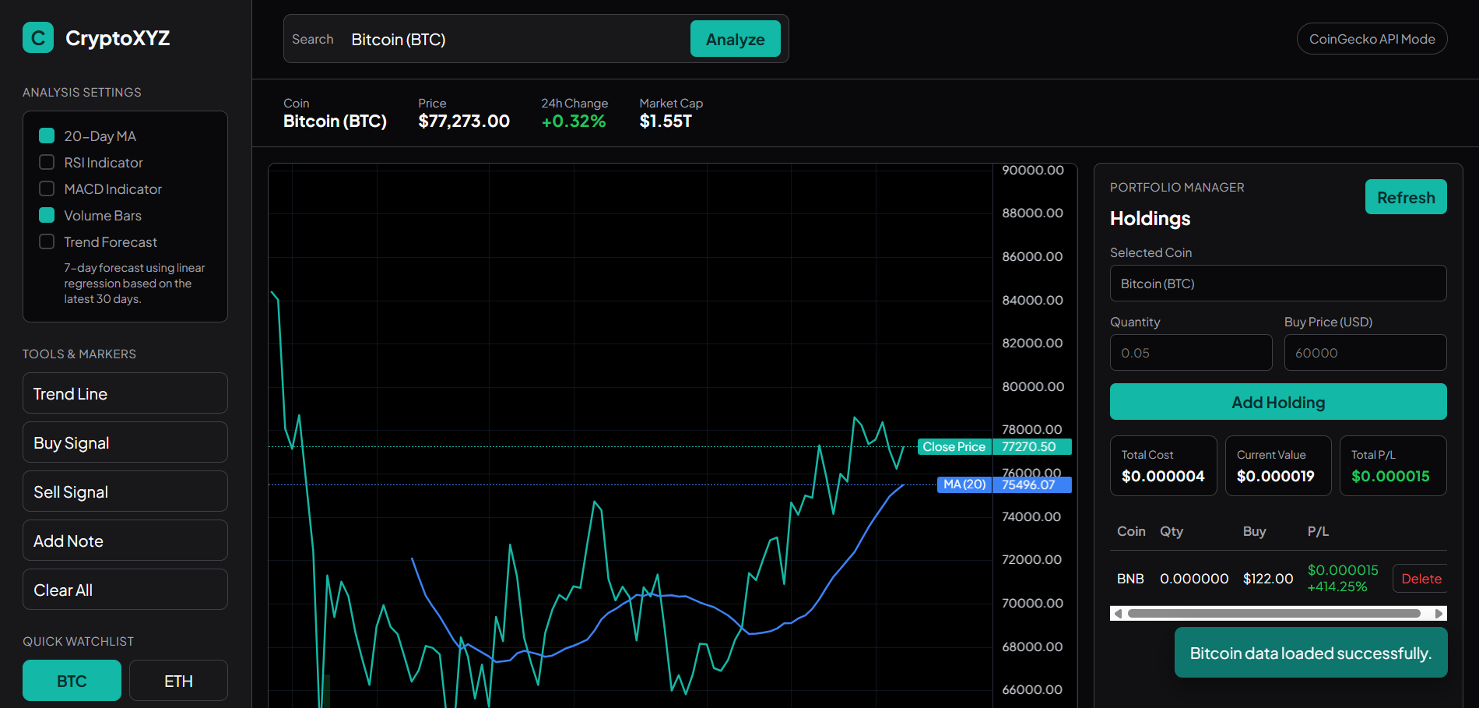
Figure 1: Main Dashboard with Bitcoin Data Loaded
The main CryptoXYZ dashboard shown when users first open the application. Bitcoin data loads automatically, with the sidebar controls on the left, the price chart in the center, and the portfolio manager on the right.

2) Cryptocurrency Search Suggestions
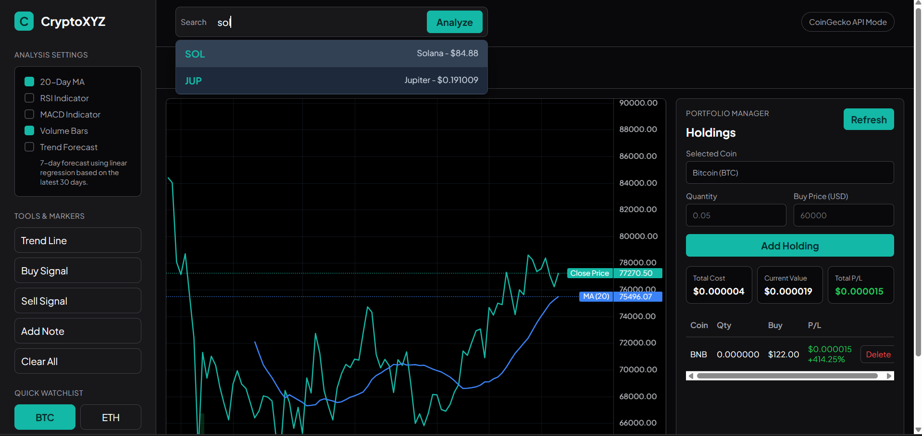
Figure 2: Cryptocurrency Search Suggestions

When a user types a coin name or symbol such as "Ethereum" or "ETH", the system shows matching cryptocurrencies in a dropdown below the search bar, including the coin symbol, name, and current price.

Figure 3: Cryptocurrency Analysis with Multiple Indicators
This shows the chart for a selected cryptocurrency with indicators enabled, including the 20-Day Moving Average, RSI, MACD, and volume bars. These indicators help users analyze market trend and momentum.

Figure 4: Interactive Drawing Tools in Use
A demonstration of the chart tools. The chart shows a user-drawn trend line, a green Buy marker, a red Sell marker, and a Note marker with custom text.

Figure 5: Price Prediction Feature
The dashed gold line extending beyond the latest date shows the 7-day trend forecast. It is generated using linear regression based on the latest 30 days of closing prices.

Figure 6: Portfolio Manager with Profit/Loss Calculation
This shows the portfolio panel after a holding is added. The system calculates total cost, current value, profit or loss amount, and profit or loss percentage.

Figure 7: Error Handling Example
This shows the error message displayed when users enter invalid input, such as an empty search, invalid coin name, or invalid portfolio value. The system shows a clear message instead of crashing.

Figure 8: Mobile Responsive Layout
The application running on a smaller screen size. The sidebar moves to the top, while the chart and portfolio panel resize and stack vertically to fit the screen.


Figure 2: Cryptocurrency Search Suggestions
This screenshot shows the search suggestion feature. When the user types a coin name or symbol, the system displays matching cryptocurrencies with their symbols and current prices.

Figure 3: Selected Cryptocurrency Market Information
Caption:
This screenshot shows the dashboard after selecting another cryptocurrency such as Ethereum or Solana. The ticker bar displays the selected coin name, current price, 24-hour percentage change, and market capitalization.

Figure 4: Technical Indicators Enabled
Caption:
This screenshot shows the chart with technical indicators enabled, including Moving Average, RSI, MACD, and trading volume. These indicators help users analyze price trend and market momentum.

Figure 5: Trend Forecast Feature
Caption:
This screenshot shows the 7-day trend forecast line. The forecast is generated using linear regression based on the latest 30 days of closing prices and is displayed as a dashed line on the chart.

Figure 6: Interactive Chart Tools
Caption:
This screenshot shows the interactive chart tools. Users can draw trend lines and add buy signals, sell signals, or personal note markers directly on the chart.

Figure 7: Portfolio Manager with Profit/Loss Calculation
Caption:
This screenshot shows the portfolio management module after a holding is added. The system calculates total cost, current value, total profit or loss, and profit or loss percentage based on the latest market price.

Figure 8: Error Handling Example
Caption:
This screenshot shows the system displaying a clear error message when the user enters invalid input, such as an empty search field or invalid portfolio quantity. This prevents the system from crashing and improves user experience.

Figure 9: Responsive Mobile Layout
Caption:
This screenshot shows the responsive layout on a smaller screen size. The sidebar, chart area, ticker information, and portfolio panel are rearranged to fit mobile or tablet devices.

Figure 1: Initial Landing Page
The welcome screen that appears when users first open the application. It shows a clean interface with the sidebar on the left containing all the analysis controls, and a message in the center prompting users to search for a stock.

Figure 2: Search Suggestions
When a user types "Apple" in the search box, the system shows matching companies like Apple Inc. (AAPL). The suggestions appear in a dropdown below the search bar.

Figure 3: Apple Stock Analysis with Multiple Indicators
This shows the chart for Apple Inc. with several indicators enabled: the blue 20-Day Moving Average line, the pink RSI indicator, the purple MACD line, and the volume bars at the bottom. The candlestick chart shows price movements over time.

Figure 4: Interactive Drawing Tools in Use
A demonstration of the drawing tools. The chart shows a white trend line drawn by the user, a green "Buy" marker at a low point, a red "Sell" marker at a high point, and a yellow "Note" marker with custom text.

Figure 5: Price Prediction Feature
The dashed gold line extending beyond the current date shows the 7-day price prediction based on linear regression analysis of the past 30 days.

Figure 6: Mobile Responsive Layout
The application running on a mobile device. The sidebar moves to the top of the screen, and the chart resizes to fit the smaller screen width.
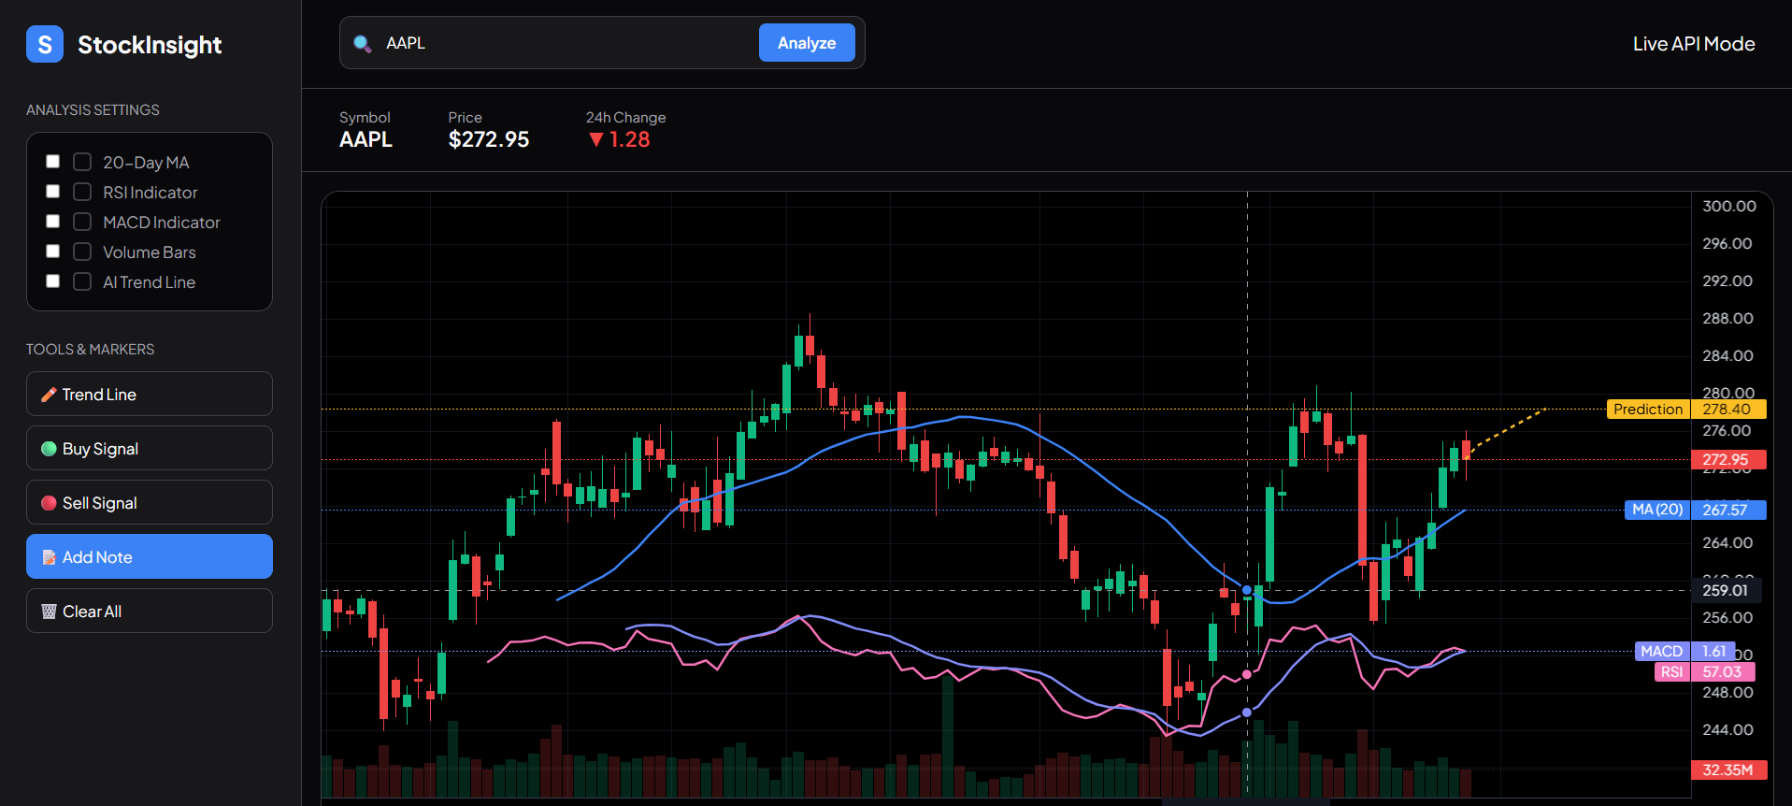

6.0 EXPLANATION OF IMPORTANT SOURCE CODE

6.1 API Request and Error Handling Function (fetchJson)
async function fetchJson(url) {
const response = await fetch(url);
if (!response.ok) {
if (response.status === 429) {
throw new Error('CoinGecko rate limit reached. Please wait a moment and try again.');
}
throw new Error(`Network request failed (${response.status}).`);
}
return response.json();
}
Explanation:
The fetchJson function is used to send a request to the CoinGecko API and get data from it. It uses fetch() to connect to the external API.
This function is written using async and await. This means the system can wait for the response without freezing the webpage.
If the request is not successful, the function will handle the error properly. For example:
- If the status is 429, it means too many requests, so the user needs to wait.
- If other errors happen, a general error message will be shown.
If the request is successful, the data will be converted into JSON format and returned. This makes the function reusable in different parts of the system.

6.2 Cryptocurrency Market Data Loading Function (loadMarketList)
async function loadMarketList(force = false) {
if (marketList.length && !force) return marketList;
const url = `${API_BASE}/coins/markets?vs_currency=${VS_CURRENCY}&order=market_cap_desc&per_page=250&page=1&sparkline=false&price_change_percentage=24h`;
marketList = await fetchJson(url);
return marketList;}

Explanation:
The loadMarketList function is used to load cryptocurrency market data from the API. It retrieves the top 250 coins based on market value.
The data includes important information such as coin name, symbol, price, and market cap. This data is used in different features like search and dashboard.
Before calling the API, the function checks if the data already exists.
- If data exists, it will reuse it.
- If not, it will request new data from the API.
This helps reduce unnecessary API calls and improves performance.

6.3 Cryptocurrency Search Function (searchMarketCoin)
async function searchMarketCoin(query) {
await loadMarketList();
const localMatches = findCoins(query);
if (localMatches.length) return localMatches[0];

const normalized = query.trim().toLowerCase();
const searchUrl = `${API_BASE}/search?query=${encodeURIComponent(normalized)}`;
const searchResults = await fetchJson(searchUrl);
const searchCoins = searchResults.coins || [];
if (!searchCoins.length) return null;

const markets = await fetchMarketsByIds(searchCoins.slice(0, 12).map(coin => coin.id));
return markets[0] || null;
}
Explanation:
The searchMarketCoin function allows users to search for a cryptocurrency easily.
Users can type either the coin name or symbol, such as BTC or Ethereum. The function first checks the local market list.
If a match is found, it returns the result immediately. If not, it sends a request to the API to search again. This two-step process makes the search faster and more user-friendly.

6.4 Historical Data Processing Function (fetchHistoricalData)
async function fetchHistoricalData(coinId) {
const url = `${API_BASE}/coins/${coinId}/market_chart?vs_currency=${VS_CURRENCY}&days=90`;
const json = await fetchJson(url);
const buckets = new Map();

(json.prices || []).forEach(([timestamp, price]) => {
const day = toChartDate(timestamp);
if (!buckets.has(day)) {
buckets.set(day, {
time: day,
open: price,
high: price,
low: price,
close: price,
volume: 0
});
}
const item = buckets.get(day);
item.high = Math.max(item.high, price);
item.low = Math.min(item.low, price);
item.close = price;
});
return Array.from(buckets.values()).sort((a, b) => a.time.localeCompare(b.time));
}
Explanation:
The fetchHistoricalData function is used to get the past 90 days of price data for a selected coin.
The API may return many data points in one day. To make it easier to understand:
- The function groups data by date.
- It calculates daily values such as open, high, low, and close.
Finally, the data is sorted from oldest to newest so that the chart can display correctly.

6.5 Technical Indicator Calculation Functions (RSI and MACD)
function calculateRSI(data, period = 14) {
const results = [];
let avgGain = 0;
let avgLoss = 0;

for (let i = 1; i < data.length; i++) {
const change = data[i].close - data[i - 1].close;
const gain = Math.max(0, change);
const loss = Math.max(0, -change);

if (i <= period) {
avgGain += gain / period;
avgLoss += loss / period;
} else {
avgGain = (avgGain * (period - 1) + gain) / period;
avgLoss = (avgLoss * (period - 1) + loss) / period;
}

if (i >= period) {
const rs = avgGain / (avgLoss || 1);
results.push({ time: data[i].time, value: 100 - (100 / (1 + rs)) });
}
}
return results;
}

function calculateMACD(data) {
const closes = data.map(item => item.close);
const ema12 = calculateEMA(closes, 12);
const ema26 = calculateEMA(closes, 26);
return data.map((item, index) => ({
time: item.time,
value: ema12[index] - ema26[index]
})).slice(26);
}

Explanation:
The system includes two indicators: RSI and MACD.
The RSI function measures the strength of price movement. It compares price increases and decreases to calculate a value between 0 and 100.
The MACD function shows the trend direction. It calculates two moving averages and finds the difference between them.
Both indicators return data in a format that can be directly shown on the chart. This helps users understand market trends better.

6.6 Price Prediction Function Using Linear Regression (calculatePrediction)
function calculatePrediction(data) {
const n = Math.min(data.length, 30);
const subset = data.slice(-n);
let sx = 0;
let sy = 0;
let sxy = 0;
let sx2 = 0;

subset.forEach((item, index) => {
sx += index;
sy += item.close;
sxy += index * item.close;
sx2 += index * index;
});

const denominator = n * sx2 - sx * sx;
if (denominator === 0) return [];

const slope = (n * sxy - sx * sy) / denominator;
const intercept = (sy - slope * sx) / n;
}

Explanation:
The calculatePrediction function provides a simple price prediction feature using linear regression.
It uses the latest 30 days of data to estimate a trend line. The function calculates:
- Slope → shows whether price is going up or down
- Intercept → used to estimate future values
Based on this, the system generates a future price line. However, this is only an estimation and not guaranteed.

6.7 Portfolio Management and Profit/Loss Calculation

portfolio.push({
coinId: activeCoin.id,
name: activeCoin.name,
symbol: activeCoin.symbol,
quantity,
buyPrice,
lastPrice: activeCoin.current_price,
addedAt: new Date().toISOString()
});
savePortfolio(portfolio);

const cost = holding.quantity * holding.buyPrice;
const value = holding.quantity * currentPrice;
const profitLoss = value - cost;
const profitLossPercent = cost > 0 ? (profitLoss / cost) * 100 : 0;
Explanation:
The portfolio feature allows users to save their cryptocurrency holdings.
Each record includes coin name, quantity, and buy price. The data is stored in localStorage, so it will not be lost after refresh.
The system calculates profit and loss using simple formulas:
- Cost = quantity × buy price
- Value = quantity × current price
- Profit/Loss = value – cost
This helps users track their investment performance easily.

6.8 Interactive Chart Tools
chart.subscribeClick(param => {
if (!param || !param.time || !activeTool) return;

const price = priceSeries.coordinateToPrice(param.point.y);
if (price === null) return;
if (activeTool.startsWith('marker-')) {
customMarkers.push({
time: param.time,
position,
color,
shape,
text: label
});
priceSeries.setMarkers(customMarkers);
return;
}
if (activeTool === 'line') {
// First click saves the start point.
// Second click creates the trend line.
}
});
Explanation:
The system provides interactive tools for the chart.
Users can click on the chart to:
- Draw trend lines (using two clicks)
- Add markers such as buy or sell points
These features allow users to analyze price movements visually and make better decisions.

6.9 Loading Feedback and Safe HTML Output
function setSearchLoading(isLoading) {
searchBtn.disabled = isLoading;
searchBtn.innerText = isLoading ? 'Loading...' : 'Analyze';
}

function escapeHTML(value) {
return String(value)
.replace(/&/g, '&amp;')
.replace(/</g, '&lt;')
.replace(/>/g, '&gt;')
.replace(/"/g, '&quot;')
.replace(/'/g, '&#39;');
}
Explanation:
The system improves user experience and safety.
During loading, the button will show “Loading…” and be disabled. This prevents users from clicking multiple times.
For security, the escapeHTML function is used. It converts special characters into safe format to prevent unwanted HTML issues.
This helps ensure the system is stable and secure.

7.0 CONTRIBUTION
This assignment was completed individually by me.

Design and Planning:
- Researched how CoinGecko displays cryptocurrency data
- Planned the layout and color scheme for a dark mode cryptocurrency dashboard.
- Designed the interface with a sidebar, search bar, ticker summary, chart area and portfolio manager.
- Decided to include common technical indicators such as Moving Average, RSI, MACD, and trading volume.
- Planned a simple prediction feature using linear regression because it is suitable for a client-side JavaScript project.

Implementation:
- Wrote the HTML structure for sidebar, search bar, ticker bar, chart container, and portfolio panel.
- Created the CSS styling for the dark mode interface, buttons, forms, table, toast message, and responsive layout.
- Programmed the JavaScript functionality for cryptocurrency search, API requests, data processing, chart rendering, technical indicators, prediction, and portfolio management.
- Integrated the CoinGecko API to retrieve real-time cryptocurrency market data and historical price data.
- Integrated the TradingView Lightweight Charts library to display the interactive price chart.
- Implemented chart tools such as trend line drawing, buy marker, sell marker, note marker, zooming, and panning.
- Used localStorage to save portfolio holdings in the browser without using a database.

Testing:
- Tested search function and using multiple cryptocurrencies such as Bitcoin, Ethereum, Solana, BNB, XRP, and Dogecoin.
- Verified that the current price, 24-hour change, market capitalization, historical chart, and volume data are displayed correctly.
- Tested the Moving Average, RSI, MACD, and trend forecast toggles.
- Tested the portfolio manager by adding and deleting holdings and checking the profit/loss calculation.
- Checked the responsive layout on different screen sizes.
- Tested error handling for empty search input, invalid coin search, invalid portfolio quantity, invalid buy price, network errors, and API rate limit messages.

8.0 CONCLUSION
This project successfully demonstrates a working cryptocurrency price monitoring, prediction and portfolio management system built using HTML5, CSS3, and JavaScript. The system meets the main requirements stated in the assignment guideline because it allows users to search cryptocurrency data, view real-time and historical prices, apply technical analysis indicators, use interactive chart tools, generate a simple forecast and manage crypto holdings.

Next, Users can search for cryptocurrencies such as Bitcoin, Ethereum, Solana, BNB, XRP, and other coins. After a coin is selected, the system displays important market information such as current price, 24-hour percentage change and market capitalization. The historical price movement is shown using an interactive chart and users can enable Moving Average, RSI, MACD, volume bars and a 7-day trend forecast.

The prediction feature uses linear regression based on the latest 30 days of closing prices. Although it is a simple statistical method, it is suitable for this assignment because it clearly demonstrates how JavaScript can process historical data and estimate a future trend. The forecast should be understood as a basic trend estimate, not financial advice.

The portfolio manager allows users to record their cryptocurrency holdings by entering quantity and buy price. The system calculates total cost, current value, profit or loss amount, and profit or loss percentage. The data is saved using localStorage, so the portfolio remains available after refreshing the browser while still following the assignment rule of not using a server-side script or database.

The application also handles errors properly. It shows clear messages when the user enters empty input, searches for an invalid coin, enters invalid portfolio values, or when API/network problems occur. Then, Responsive design also allows the system to be used on different screen sizes.

Through building this project, I learned how to:
- Work with an external cryptocurrency API using asynchronous JavaScript.
- Process real-time and historical market data.
- Use a charting library to create an interactive financial dashboard.
- Implement technical indicators such as Moving Average, RSI, and MACD.
- Create a simple price prediction feature using linear regression.
- Store user portfolio data using localStorage.
- Design a responsive dark mode interface using CSS Grid, Flexbox, and media queries.
- Improve user experience with loading feedback, search suggestions, and error messages.

If I continue developing this project in the future, I would add price alerts, candlestick chart support, more advanced prediction models, portfolio performance charts, and the ability to compare multiple cryptocurrencies on the same chart.

Overall, CrytoXYZ is a complete client-side web application that combines cryptocurrency monitoring, technical analysis, trend prediction, and portfolio evaluation in one user-friendly system.

9.0 Appendix Source Code

9.1 index.html

Reference
Cryptocurrency Data API
- CoinGecko. (2026). CoinGecko API documentation: Endpoint overview.
https://docs.coingecko.com/reference/endpoint-overview
- CoinGecko. (2026). Coins list with market data API.
https://docs.coingecko.com/reference/coins-markets
- CoinGecko. (2026). Coin historical chart data by ID API.
https://docs.coingecko.com/reference/coins-id-market-chart
- CoinGecko. (2026). Search queries API.
https://docs.coingecko.com/reference/search-data

Charting Library
- TradingView. (2026). Lightweight Charts documentation.
https://tradingview.github.io/lightweight-charts/

Web Technologies
- MDN Web Docs. (2026). Fetch API.
https://developer.mozilla.org/en-US/docs/Web/API/Fetch_API
- MDN Web Docs. (2026). await – JavaScript.
https://developer.mozilla.org/en-US/docs/Web/JavaScript/Reference/Operators/await
- MDN Web Docs. (2026). Web Storage API.
https://developer.mozilla.org/en-US/docs/Web/API/Web_Storage_API

Technical Analysis and Prediction
- Investopedia. (2025). Moving average (MA): Purpose, uses, formula, and examples.
https://www.investopedia.com/terms/m/movingaverage.asp
- Investopedia. (2026). Relative strength index (RSI): What it is, how it works, and formula.
https://www.investopedia.com/terms/r/rsi.asp
- Investopedia. (2026). Moving average convergence divergence (MACD).
https://www.investopedia.com/terms/m/macd.asp
- Khan Academy. (2026). Linear regression review.
https://www.khanacademy.org/math/statistics-probability/describing-relationships-quantitative-data/introduction-to-trend-lines/a/linear-regression-review

目前感觉就是手机website screenshot
1. Introduction (1-2 mins)
"Hello everyone, my name is Yeap Boon Shen. Today I will present my individual assignment for Web Techniques: StockInsight. This application is designed to simplify stock market analysis by providing a user-friendly interface that translates complex financial data into interactive visualizations."
2. Interface & Navigation (2 mins)
"As you can see, I chose a Professional Dark Mode theme. On the left is the Control Sidebar where users can toggle indicators and select drawing tools. The top features a search bar with Real-time Suggestions. I used a responsive Flexbox layout, meaning the sidebar adapts if viewed on a mobile device."
3. Feature Demonstration (5-7 mins)
- Search: "I'll search for 'Apple'. Notice the suggestion box powered by the Alpha Vantage API. Selecting 'AAPL' fetches live daily data."
- Charts & Indicators: "The main chart is a Candlestick series. I can toggle the 20-day Moving Average, RSI, and MACD. These are calculated in the background using JavaScript."
- Interactive Tools: "Traders need to mark their thoughts. I can draw a Trend Line by clicking two points. I can also mark a 'Buy' signal at this support level."
- Prediction: "The dashed gold line represents a 7-day forecast. This is calculated using Linear Regression on the last 30 days of closing prices."
4. Code Probing (Self-Code Modification) (2-3 mins)
(这是展示你对代码理解的关键部分)
A. 修改颜色 (Change Color Styles)
"To change the theme color, I can simply go to my style.css and modify the --accent variable."
- 操作: 把 :root 里的 --accent: #3b82f6; 改成 #a855f7 (Purple)。保存刷新，按钮和 Logo 都会变紫色。
B. 重命名 Function (Renaming a Function)
"I will rename the calculateRSI function to getRelativeStrengthIndex to show code modularity."
- 操作: 在 script.js 搜索 calculateRSI，将其定义和调用处全部修改。证明程序依然运行正常。
C. 添加新功能 (Adding a new line/feature)
"Let's add a simple alert that shows the current price when we click the Analyze button."
- 操作: 在 updateDashboard 函数末尾添加：
alert("Now viewing data for: " + symbol);
5. Conclusion & Future Work (1 min)
"In conclusion, this project enhanced my skills in asynchronous API handling and state management. For future work, I plan to add Portfolio Tracking and Export to PDF features to help users save their analysis."

